Schedule WEDNES December 9th :
Lesson 10A – Tenses part 1.

- Admin Get the list updated and name tags
- Class emails
- Slideshow with results
- Repetition of Adverbs Video 30 secs and from 17:50
- Grammar 10 – Tenses Lecture
- Grammar 10 – Tenses Video 20 min to Future Tense
- Grammar 10 – Tenses Test
- https://www.facebook.com/mshoatoeic/videos/1991632460928172/
Video from English class.

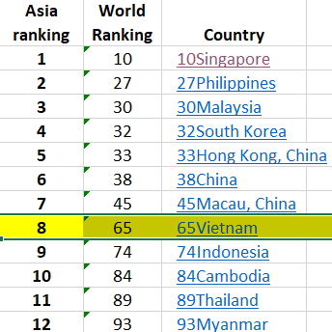

Corruption
is "the misuse of public power for private benefit".
Lạm dụng quyền lực công để tư lợi
How?
In economics, a market is transparent if much is known by many about:

- What products are available
- Services are available
- Capital assets are available
- Market depth
- What price
- Where

Transparency
is important since it is one of the theoretical conditions required for a free market to be efficient

Odds and Ends or "Sundry" (đồ lặt vặt). (crazykims.vn)
http://www.crazykims.vn/oddsandends.htm

English proficiency in South East Asia.
1 | Singapore 611 | Netherlands | 652
2 | Philippines | Denmark | 632
3 | Malaysia | Finland | 631
4 | South Korea | Sweden | 625
5 | Hong Kong | Norway | 624
6 | China 520
7 | Vietnam
8 | Indonesia
9 | Cambodia
10 | Thailand
11 | Myanmar
https://vimeo.com/111098263?autoplay=1

