Schedule WEDNESDAY January 20th, 2021
Lesson 9 – Adverbs modify a verb, an adjective, or another adverb.
- Admin Get the list updated and name tags.
- Past results
- Gen. Vo Nguyen Giap 1 minute video
- Grammar 9 – Adverbs modify a verb, an adjective, or another adverb Lecture
- Grammar 9 – Adverbs modify a verb, an adjective, or another adverb Video
- Gen. Vo Nguyen Giap 2 minutes video
- Adverbs of Time Quiz 🤔 | Vocabulary | EnglishClub
Adverbs of Manner Quiz 🤔 | Vocabulary | EnglishClub

- Fruit guessing game
  - Ask 5 question about the fruit
    - Is the fruit green?
    - Is it big (show with hands)?
    - Does it taste sweet?
    - Does it have pits(seeds)?
    - Is the flesh white?
  - Guess the fruit

English Proficiency Index:
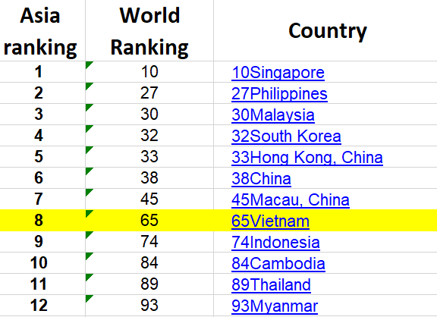
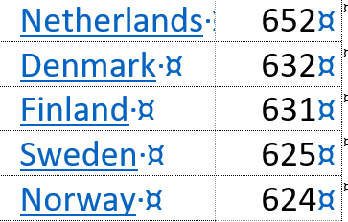

Corruption Index:

Corruption
is "the misuse of public power for private benefit".
Lạm dụng quyền lực công để tư lợi
How?
In economics, a market is transparent if much is known by many about:

- What products are available
- Services are available
- Capital assets are available
- Market depth
- What price
- Where

Transparency
is important since it is one of the theoretical conditions required for a free market to be efficient

Odds and Ends or "Sundry" (đồ lặt vặt). (crazykims.vn)
http://www.crazykims.vn/oddsandends.htm

English proficiency in South East Asia.
1 | Singapore 611 | Netherlands | 652
2 | Philippines | Denmark | 632
3 | Malaysia | Finland | 631
4 | South Korea | Sweden | 625
5 | Hong Kong | Norway | 624
6 | China 520
7 | Vietnam
8 | Indonesia
9 | Cambodia
10 | Thailand
11 | Myanmar
https://vimeo.com/111098263?autoplay=1

