Martin’s 17 basic (elementary) grammar lessons of 297.
- A noun names a person, place, thing, or idea. A naming word.
- Count noun, a noun that can form a plural.
- Possessive nouns are used to indicate ownership.
- Pronoun takes the place of a noun.
- 'Be' Verbs. A verb shows action or a state of being.

- Action verbs, also called dynamic verbs, express an action, whether it be physical or mental.
- Adjectives describe or modify noun.
- Comparative and Superlative Adjectives.
- Adverbs modify a verb, an adjective, or another adverb.

- Tense of a verb tells you when the action happens.
- Progressive Tense, involves action that is, was, or will be in progress.
- Perfect continuous tense shows that something started in the past and is continuing at the present time.

- Prepositions "On," "At," and "In” links a noun, pronoun, or noun phrase to some other part of the sentence.
- Prepositions "Of," "To," and "For" links a noun, pronoun, or noun phrase to some other part of the sentence.
- Prepositions "With," "Over," and "By" links a noun, pronoun, or noun phrase to some other part of the sentence.
- Grammar 24A: Prepositions recap

A preposition is a word or group of words used before a noun, pronoun, or noun phrase to show direction, time, place, location, spatial relationships, or to introduce an object.
Translation:
,
- A subject does something to the object.
Một chủ đề làm một cái gì đó cho đối tượng.
- A verb tells what the subject wants to do.
Một động từ cho biết những gì chủ đề muốn làm.
- An object is what the subject will do something to or with.
Một đối tượng mà đối tượng sẽ làm một cái gì đó để hoặc với.

Action verbs | Động từ hành động | Plural | Số nhiều
Action | Hoạt động | Possessive | Sở hữu
Adjectives | Tính từ | Pronoun | Đại từ
Adverbs | Trạng từ | Simple | Đơn giản
Comparative | So sánh | Preposition | Thành phần
Count noun | Danh từ đếm | Progressive | Cấp tiến
Future tense | Thì tương lai | Perfect | Hoàn hảo
Noun | Danh từ | Perfect continuous | Liên tục hoàn hảo
Ownership | Quyền sở hữu | Perfect Progressive | Sự tiến bộ hoàn hảo
Past tense | Thì quá khứ | State of being | Tình trạng
Present tense | Thì hiện tại | Superlative | Siêu hạng
 |  | Tense of a verb | Thì động từ

Prepositions recap
Prepositional phrases consist of two basic parts: the preposition and the object. The object can be a noun, pronoun, or gerund
Gerund is a verb form which functions as a noun, in English ending in -ing (e.g. asking in do “Do you mind my asking you?)
Gerund là một dạng động từ có chức năng như một danh từ, trong tiếng Anh kết thúc bằng -ing, v.d. hỏi trong do “Bạn có phiền khi tôi hỏi bạn không?

In prepositional phrases, prepositions are almost always followed by an object.

Prepositional Phrases
Preposition | Object | Prepositional Phrase
On | The desk | On the desk
On | The phone | On the phone
At | The park | At the park
At | The stadium | At the stadium
In | The morning | In the morning
In | The car | In the car
Of | The book | Of the book
Of | My family | Of my family
To | The theater | To the theater
To | The roof | To the roof

Prepositional Phrases
Preposition | Object | Prepositional Phrase
For | Your birthday | For your birthday
For | Many years | For many years
With | French fries | With French fries
With | An accent | With an accent
Over | The moon | Over the moon
Over | An hour | Over an hour
By | The bank | By the bank
By | The mailman | By the mailman

Directions: Choose the right preposition for each sentence.
At By For In Of On Over To With
1) I put dishes ____ the table.
2) There is a party ____ the clubhouse.
3) The students stood ____ a circle.
4) The first page ____ the book describes the author's profile.
5) The package was mailed ____ his boss yesterday.
6) She has been studying hard ____the final exam.
7) I ordered a sandwich ____ a drink.
8) The cost of the repairs is ____repairman's estimate.
9) The flowers were delivered ____a delivery man.
At By For In Of On Over To With
10) She is talking ____the phone.
11) John is standing ____ the door
12) I bought clothes ____ my money.
13) The water came up ____ the house.
14) I am staying ____ a hotel.
15) I will see you ____ the party.
16) I always carry a picture ____ my children.
17) She quit her job ____personal reasons.
18) The meeting lasted ____ two hours.

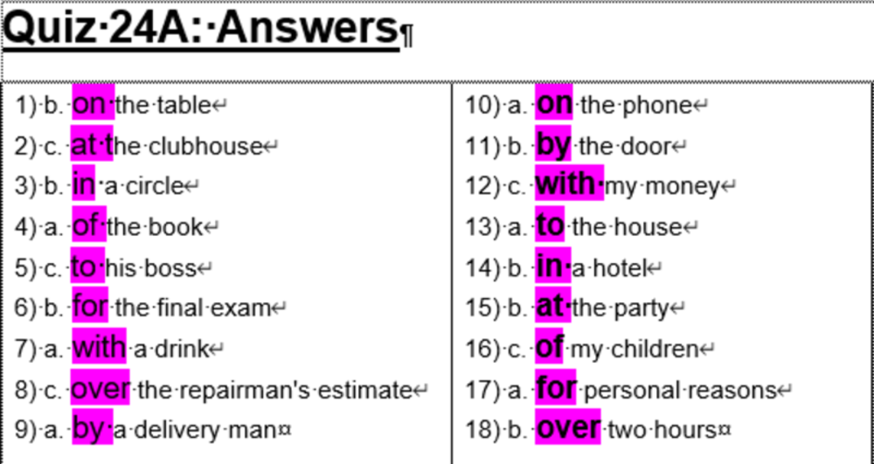
1) b. on the table  2) c. at the clubhouse  3) b. in a circle  4) a. of the book  5) c. to his boss  6) b. for the final exam  7) a. with a drink  8) c. over the repairman's estimate  9) a. by a delivery man | 10) a. on the phone  11) b. by the door  12) c. with my money  13) a. to the house  14) b. in a hotel  15) b. at the party  16) c. of my children  17) a. for personal reasons  18) b. over two hours
