http://www.crazykims.vn/grammar.htm

http://www.crazykims.vn/grammar.htm
Martin’s 16 basic (elementary) grammar lessons of 297.
- A noun names a person, place, thing, or idea. A naming word. Nouns for kids
- Count noun, a noun that can form a plural. Count nouns
- Possessive nouns are used to indicate ownership. Possessive nouns
- Pronoun takes the place of a noun. Pronoun song
- 'Be' Verbs. A verb a state of being. Be-vebs
- Action verbs, also called dynamic verbs, express an action, whether it be physical or mental.
Action verbs for kids
- Adjectives describe or modify noun. What is an adjective?
- Comparative and Superlative Adjectives. Video Start at 7:10
- Adverbs modify a verb, an adjective, or another adverb. Adverb for children.
- Tense of a verb tells you when the action happens. Tenses for children
- Progressive Tense, involves action that is, was, or will be in progress. Present continuous
- Perfect continuous tense shows that something started in the past and is continuing at the present time.
Video on Past Perfect Continuous 0000-0130.

Never say nothing, if you don’t know, say so. Never answer with one word but with a subject and verb using intransitive verbs, and an object if you have a transitive verb.

A subject does something to the object.
Một chủ đề làm một cái gì đó cho đối tượng.
A verb tells what the subject wants to do.
Một động từ cho biết những gì chủ đề muốn làm.
An object is what the subject will do something to or with.
Một đối tượng mà đối tượng sẽ làm một cái gì đó để hoặc với.

Only transitive verbs take an object like kick and throw. Kick what?
Intransitive (stative) verbs do not take an object like agree, appear, arrive, happen, leave, lie, listen, panic, smile, talk, work, and yell.

Why do we learn? Because we want to.
How much do you want to learn (motivated are you) on a scale from 1 – 10?

The perfect continuous tense
Translation: | Tiếng Việt Translation:
Present Simple | Hiện tại đơn
Present Continuous | Thì hiện tại tiếp diễn
Present Perfect | Hiện tại hoàn thành
Present Perfect Continuous | Hiện tại hoàn thành tiếp diễn
Past Simple | Qua khư đơn
Past Continuous | Quá khứ tiếp diễn
Past perfect | Quá khứ hoàn thành
Past perfect Continuous | Quá khứ hoàn thành tiếp diễn
Future Simple | Tương lai đơn
Future Continuous | Tương lai tiếp diễn
Future Perfect | Tương lai hoàn hảo
Future Perfect Continous | Tương lai hoàn hảo liên tục
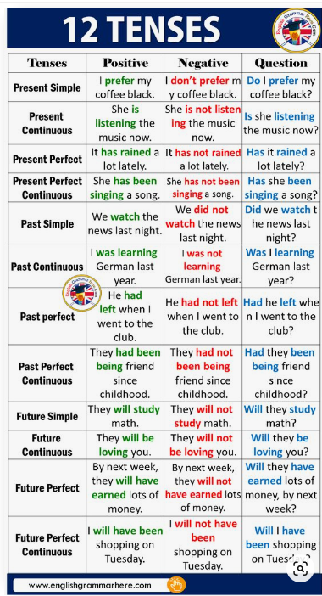
The (past, present & future) perfect progressive tense describes actions that

- repeated over a period of time in the past,
- are continuing in the present, and/or
- will continue in the future.
The present perfect progressive tense tells you about a continuous action that was initiated in the past and finished at some point in the past; however, the action has some relation to the present time. Use have/has + been + ing.
- It has been raining, and the street is still wet.
- I have been running, and I am still tired.
- She has been practicing the piano, and she is much better now.
The past perfect progressive tense illustrates a continuous action in the past that was completed before another past action. Use had + been + ing.
- It had been raining, and the street was still wet.
- I had been running, and I was still tired.
- She had been practicing the piano, and she had gotten much better.
The future perfect progressive tense indicates a continuous action that will be completed in the future. Use will + have + been + ing.
- By tonight, it will have been raining several hours, and the street will be very wet.
- By next summer, I will have been running for almost a year, and I will be fit and healthy.
- By the time of the concert, she will have been practicing the piano for several months, and she will be much better.
HAVE BEEN / HAS BEEN / HAD BEEN
Present Continuous & Past Perfect Continuous tense.
What is the difference?
Ganesh will explain.

Video on Past Perfect Continuous
0000-0130 &0900-1300.

