Martin’s 10 basic (elementary) grammar lessons of 297.

- A noun names a person, place, thing, or idea. A naming word.
- Count noun, a noun that can form a plural.
- Possessive nouns are used to indicate ownership.
- Pronoun takes the place of a noun.
- 'Be' Verbs. A verb shows action or a state of being
- Action verbs, also called dynamic verbs, express
an action, whether it be physical or mental.
- Adjectives describe or modify noun.
- Comparative and Superlative Adjectives.
- Adverbs modify a verb, an adjective, or another adverb.
- Tense of a verb tells you when the action happens.
- Continuous Tense, involves action that is, was, or will be in progress. Intro, present continuous.
- Perfect continuous tense

- A subject does something to the object.
Một chủ đề làm một cái gì đó cho đối tượng.
- A verb tells what the subject wants to do.
Một động từ cho biết những gì chủ đề muốn làm.
- An object is what the subject will do something to or with.
Một đối tượng mà đối tượng sẽ làm một cái gì đó để hoặc với.

Continuous Tense, involves action that is, was, or will be in progress

 | Tiếng Việt Translation:
Present Simple | Hiện tại đơn
Present Continuous | Thì hiện tại tiếp diễn
Present Perfect | Hiện tại hoàn thành
Present Perfect Continuous | Hiện tại hoàn thành tiếp diễn
Past Simple | Qua khư đơn
Past Continuous | Quá khứ tiếp diễn
Past perfect | Quá khứ hoàn thành
Past perfect Continuous | Quá khứ hoàn thành tiếp diễn
Future Simple | Tương lai đơn
Future Continuous | Tương lai tiếp diễn
Future Perfect | Tương lai hoàn hảo
Future Perfect Continuous | Tương lai hoàn hảo liên tục
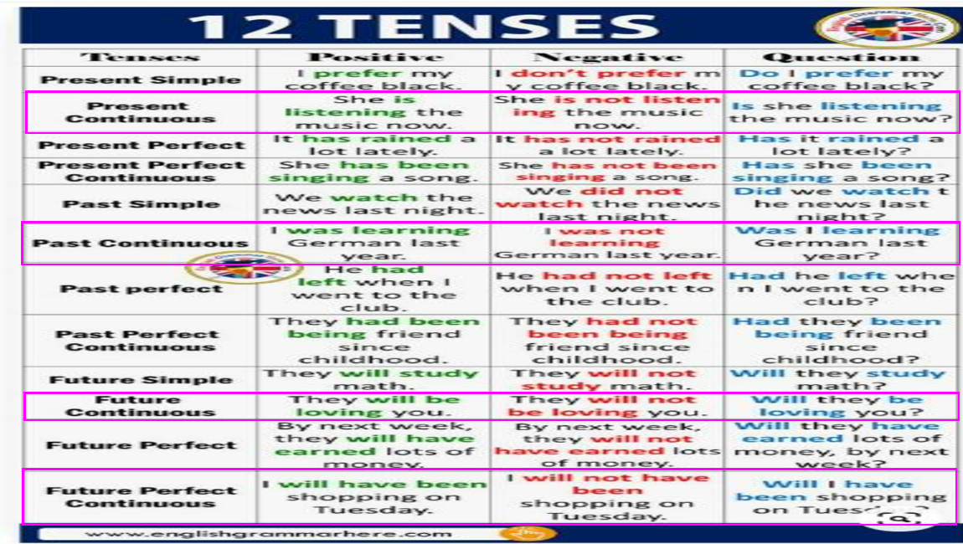

run
- I am running a marathon right now. (present Continuous)
- I was running a marathon at this time last year. (past Continuous)
- I will be running a marathon next Sunday. (future Continuous)
eat
- I am eating lunch now.
- I was eating lunch when you saw me.
- I will be eating lunch in the meeting.
learn
- I am learning English at my desk.
- I was learning English the last two years.
- I will be learning English then.

Continuous Tense, involves action that is, was, or will be in progress.

cook
- I am cooking my supper now.
- I was cooking our dinner when you called me.
- I will be cooking breakfast by the time you come home.

Perfect Tense
The present perfect tense describes an action that started
- in the past and
- continues to the present time.

Use has/have + the past participle form of the verb.
The past perfect tense describes an action that started and ended in the past. Use had + the past participle form of the verb.

Continuous Tense, involves action that is, was, or will be in progress

The future perfect tense describes future actions that will occur before some other action. Use will have + the past participle form of the verb.
run
- I have run several marathons this year. (present perfect)
- I had run many marathons in the past. (past perfect)
- I will have run a marathon by the time I turn 30. (future perfect)
learn
- I have learned a lot about English grammar this semester.
- I had learned the basics of English grammar in elementary school.
- I will have learned a lot about English grammar when I finish college.

Continuous Tense, involves action that is, was, or will be in progress
know
- I have known her since I was young.
- I had known her until she passed away.
- I will have known her for 20 years next month.
cook
- I have cooked supper every night this week.
- I had cooked supper every night until the stove broke.
- I will have cooked supper every night by the time this diet ends.

