http://www.crazykims.vn/grammar.htm
Martin’s 16 basic (elementary) grammar lessons of 297.

- A noun names a person, place, thing, or idea. A naming word. Grammar summary
- Count noun, a noun that can form a plural. Count nouns
- Possessive nouns are used to indicate ownership. Possessive nouns
- Pronoun takes the place of a noun. Pronoun song
- 'Be' Verbs. A verb a state of being. Be-vebs

- Action verbs, also called dynamic verbs, express an action, whether it be physical or mental. Action verbs for kids
- Adjectives describe or modify noun. What is an adjective?
- Comparative and Superlative Adjectives.
- Adverbs modify a verb, an adjective, or another adverb.
- Tense of a verb tells you when the action happens.

- Progressive Tense, involves action that is, was, or will be in progress.
- Perfect continuous tense shows that something started in the past and is continuing at the present time.

Never say nothing, if you don’t know, say so. Never answer with one word but with a subject and verb using intransitive verbs, and an object if you have a transitive verb.

A subject does something to the object.
Một chủ đề làm một cái gì đó cho đối tượng.
A verb tells what the subject wants to do.
Một động từ cho biết những gì chủ đề muốn làm.
An object is what the subject will do something to or with.
Một đối tượng mà đối tượng sẽ làm một cái gì đó để hoặc với.

Only transitive verbs take an object like kick and throw. Kick what?
Intransitive (stative) verbs do not take an object like agree, appear, arrive, happen, leave, lie, listen, panic, smile, talk, work, and yell.

Why do we learn? Because we want to.
How much do you want to learn (motivated are you) on a scale from 1 – 10?

Grammar07: Adjectives describe or modify nouns. Tính từ mô tả hoặc sửa đổi danh từ
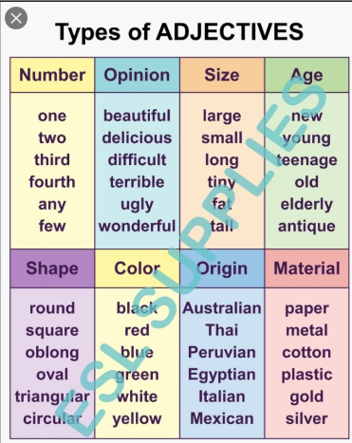

An adjective (Tính từ) describes or modifies a noun. It provides further information about a noun, indicating things like number, opinion, size, age, shape, color, origin, material, and more. Adjectives can also modify pronouns.
I like fairy tales. A fairy tale is an imaginary story that has unrealistic characters in a fantastic background. It makes me forget about the real world and refreshes my tired mind.
Tôi thích truyện cổ tích. Một câu chuyện cổ tích là một câu chuyện tưởng tượng có các nhân vật phi thực tế trong một bối cảnh tuyệt vời. Nó làm tôi quên đi thế giới thực và làm mới tâm trí mệt mỏi của tôi.

Adjectives generally appear immediately before the noun.
Tính từ thường xuất hiện ngay trước danh từ.
- Red flowers
- A pretty girl
- A long stick
- Heavy boxes
- Warm weather
Commonly, adjectives of opposite(đối mặt) meaning are formed by adding a prefix (chức tước) such as un, in, or dis.
- clear – unclear rõ ràng - không rõ ràng
- important – unimportant quan trọng - không quan trọng
- predictable – unpredictable có thể dự đoán - không thể đoán trước
- believable – unbelievable đáng tin - không thể tin được
- common – uncommon phổ biến - không phổ biến
- aware – unaware nhận biết - không biết
- ambiguous – unambiguous mơ hồ - không rõ ràng
- definite – indefinite xác định - không xác định
- correct – incorrect đúng - không chính xác
- expensive – inexpensive đắt - rẻ
- able – disable có thể - vô hiệu hóa
- assemble – disassemble lắp ráp - tháo rời
- content – discontent nội dung - bất mãn
- similar – dissimilar tương tự - không giống nhau

When using a string of adjectives, they should appear in a set order:
size/shape + age + color + origin + material.
Khi sử dụng một chuỗi tính từ, chúng sẽ xuất hiện theo thứ tự được đặt:
kích thước / hình dạng + tuổi + màu sắc + nguồn gốc + vật liệu.
- A big brown house
- A small old English desk
- A beautiful black Italian leather purse
- Delicious Chinese food
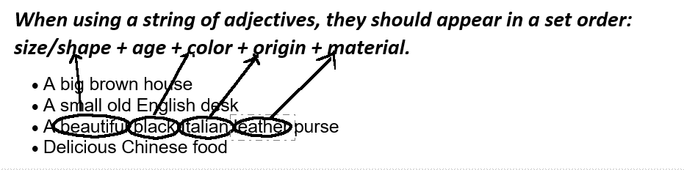

Degradable
Non-gradable adjectives are those with meanings which cannot be modified by adverbs.
Gradable adjectives.
Most adjectives are gradable. This means that their meaning can be modified (made stronger, weaker, or otherwise altered) by placing one or more adverbs in front of them.

The +(plus) adjective describes a class or group of people and acts as a noun.
Tính từ +mô tả một lớp hoặc một nhóm người và hoạt động như một danh từ.
- the old
- the young
- the poor
- the rich
- the oppressed
- the homeless
This popular TV show is loved by the old.

Do the video. Ganesh 17:30 minutes, long. Stop at 7:30, comparative and superlative adjectives.
Written test

Adjective Order Game 1.2 | EnglishClub grade 1
Recap:
Oxford video on adjectives.
Degradable Non-gradable adjectives are those with meanings which cannot be modified by adverbs.
Gradable adjectives. Most adjectives are gradable. This means that their meaning can be modified (made stronger, weaker, or otherwise altered) by placing one or more adverbs in front of them.

Quiz 7.1]
Write opposite (đối mặt, đối diện & đâu mặt nhau) adjectives using the appropriate prefix (chức tước).
Use un-, dis- or
  - Clear
  - Definite
  - Correct
  - Expensive
  - Complete
How many adjectives are there in the following sentences?
In the spring, red roses blossom in my cute small garden. The beautiful birds also sing in the big oak tree.
- _________

Fill in the correct answer: a), b) or c). Only one answer is correct.

- Andrea had a ________ in her hair yesterday.
a) nice yellow bow b) yellow nice bow c) bow nice yellow
- She lost a ________
a) small white cat b) cat small white c) white small cat
- I bought ________ oranges.
a) great some big b) big great some c) some great big
- We met ________ people at the conference.
a) very smart two b) two very smart c) very two smart
- The clown was wearing a ________ hat.
a) big green-yellow b) big green and yellow c) yellow and green big
- The cookies that you ________ .
a) smell delicious baked b) baked smell delicious c) delicious smell baked

Are the following 3 sentences correct (C) or incorrect (IC)?

- My wife and I went to see a movie. The movie was bored, so we were boring.
- The students felt really confused because the professor's lecture
was so confusing.
- The story was exiting, and the children were excited to hear it.

Answers:

- Unclear  - Indefinite  - Incorrect  - Inexpensive  - Incomplete  - 6  red, cute, small, beautiful, big, oak  - A  - A  - C | - B  - B  - B  - IC  - C  - C

