http://www.crazykims.vn/grammar.htm
Martin’s 16 basic (elementary) grammar lessons of 297.

- A noun names a person, place, thing, or idea. A naming word.
- Count noun, a noun that can form a plural.
- Possessive nouns are used to indicate ownership.
- Pronoun takes the place of a noun. Pronoun Song
- 'Be' Verbs. A verb a state of being.

- A subject does something to the object.
Một chủ đề làm một cái gì đó cho đối tượng.
- A verb tells what the subject wants to do.
Một động từ cho biết những gì chủ đề muốn làm.
- An object is what the subject will do something to or with.
Một đối tượng mà đối tượng sẽ làm một cái gì đó để hoặc với.

Only transitive verbs (động từ tạm thời) take an object like kick and throw. Kick what?
Intransitive verbs (Động từ intransitive) do not take an object like agree, appear, arrive, happen, leave, lie, listen, panic, smile, talk, work, and yell.

Grammar04: Pronoun takes the place of a noun. The Noun Song.
Đại từ Một đại từ thay thế cho một danh từ
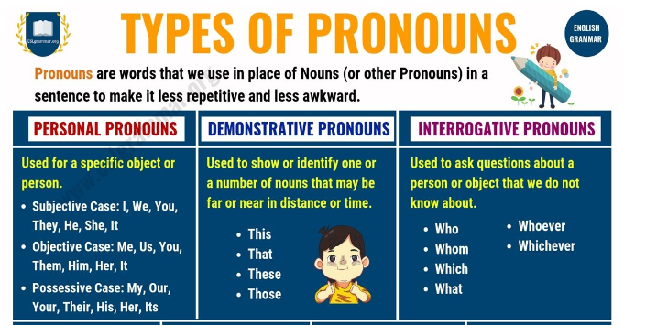

We often use pronouns to avoid having to repeat the same noun repeatedly.

Pronoun

is a word that can function by itself as a noun phrase and that refers either to the participants in the discourse (for example, I, you) or to someone or something mentioned elsewhere in the text (for example she, it, this ).

This makes our language shorter and less repetitive.

Example story:

Mary is one of the heads of the ToJi Corporation.

Mary works with Mr. James and Mr. James' son Tom.

Mr. James and Mr. James' son Tom are experts in biochemistry (hóa sinh).

Mary, Mr. James, and Tom researched and invented a drug for cancer treatment.

Translation:

If the story above is written using pronouns:

Mary is one of the heads of the ToJi Corporation.

She works with Mr. James and his son Tom.

He and his son Tom are experts in biochemistry.

They researched and invented a drug for cancer treatment.

Personal Pronouns
Personal pronouns refer to a person:
- I go to school.
- You are a student.
- They are Koreans. The plural of ‘Vietnamese’ is ‘Vietnamese’. Only use 'the” if you are speaking about a specific group of Vietnamese people.
- He works here.
- We gave her food.
The word 'it' refers to an object:
- I drank it.
- It is big.
- They cut it into halves.

Homework:
Memorize (Ghi nhớ) the personal pronouns:
 | First  person | Second  person | Third  person
 |  |  | Male | Female | Neutral
Singular Subject (Môn học số ít) | I | you | he | she | it
Singular Object (Đối tượng số ít,) | me | you | him | her | it
Singular Reflexive (Phản xạ số ít,) | myself | yourself | himself | herself | itself
Plural Subject (Chủ ngữ số nhiều) | we | you | they
Plural Object (Đối tượng số nhiều) | us | you | them
Plural Reflexive(Phản xạ số nhiều) | ourselves | yourselves | themselves

Back to schedule.
Pronoun takes the place of a noun. Video-04 , short one, long one with Ganesh and a special one, Who, Whom and Whose also with Ganesh.

