http://www.crazykims.vn/grammar.htm
Martin’s 16 basic (elementary) grammar lessons of 297.
Martin’s 16 basic (elementary) grammar lessons of 297.

- A noun names a person, place, thing, or idea. A naming word. Grammar summary
- Count noun, a noun that can form a plural. Count nouns
- Possessive nouns are used to indicate ownership. Possessive nouns
- Pronoun takes the place of a noun. Pronoun song
- 'Be' Verbs. A verb a state of being. Be-vebs

- Action verbs, also called dynamic verbs, express an action, whether it be physical or mental. Action verbs for kids
- Adjectives describe or modify noun. What is an adjective?
- Comparative and Superlative Adjectives. Video Start at 7:10
- Adverbs modify a verb, an adjective, or another adverb. Adverb for children
- The tense of a verb tells you when the action happens. Tenses for childrenProgressive Tense, involves action that is, was, or will be in progress.
- Perfect continuous tense shows that something started in the past and is continuing at the present time.
Never say nothing, if you don’t know, say so. Never answer with one word but with a subject and verb using intransitive verbs, and an object if you have a transitive verb.

A subject does something to the object.
Một chủ đề làm một cái gì đó cho đối tượng.
A verb tells what the subject wants to do.
Một động từ cho biết những gì chủ đề muốn làm.
An object is what the subject will do something to or with.
Một đối tượng mà đối tượng sẽ làm một cái gì đó để hoặc với.

Why do we learn? Because we want to.
How much do you want to learn (motivated are you?) on a scale from 1 – 10?

Only transitive verbs take an object like kick and throw. Kick what?
Intransitive (stative) verbs do not take an object like agree, appear, arrive, happen, leave, lie, listen, panic, smile, talk, work, and yell.

Grammar02: Count nouns, a noun that can form a plural. Add a S(Sierra)
Đếm danh từ, một danh từ có thể tạo thành số nhiều.
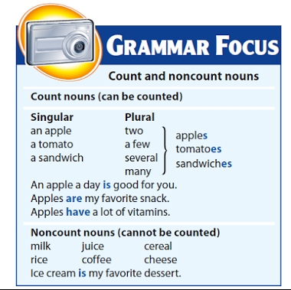

Count nouns, a noun that can form a plural.
Đếm danh từ, một danh từ có thể tạo thành số nhiều.

Can be counted as one or more.
- pen, computer, bottle, spoon, desk, cup, television, chair, shoe, finger, flower, camera, stick, balloon, book, table, comb, etc.

Take an s to form the plural.
- pens, computers, bottles, spoons, desks, cups, televisions, chairs, shoes, fingers, flowers, cameras, sticks, balloons, books, tables, combs, etc.

Work with expressions such as (a few, few, many, some, every, each, these, and the number of).
- a few pens, a few computers, many bottles, some spoons, every desk, each cup, these televisions, the number of chairs, a few shoes, a few fingers, many flowers, some cameras, every stick, each balloon, these books, the number of tables, many combs, etc.
Work with appropriate articles (a, an, or the).
- a pen, the computer, a bottle, the spoon, a desk, the cup, a television, the chair, a shoe, the finger, a flower, the camera, a stick, the balloon, a book, the table, a comb, etc.

Do NOT work with much (for example, you would never say much pens or much computers).

Non-count nouns
Cannot be counted. They usually express a group or a type.
- water, wood, ice, air, oxygen, English, Spanish, traffic, furniture, milk, wine, sugar, rice, meat, flour, soccer, sunshine, etc.
Generally, cannot be pluralized.
Work both with and without an article (a, an, or the) depending on the context of the sentence.
- Sugar is sweet. Sugars are sweet.
- The sunshine is beautiful.
- I drink milk.
- He eats rice.
- We watch soccer together.
- The wood is burning.
Work with expressions such as (some, any, enough, this, that, and much).
- We ate some rice and milk.
- I hope to see some sunshine today.
- This meat is good.
- She does not speak much Spanish.
- Do you see any traffic on the road?
- That wine is very old.
Do NOT work with expressions such as (these, those, every, each, either, or neither).

Video 1: Nouns with Anna. 19 minutes.

Quiz 2-1: Answer a), b) or c)
1. What's the plural of child? a)Children b)Childs c)Childrens
2. What's the plural of sheep? a)Sheep b)Sheeps c)Ship
3. What's the plural of dog? a)Dog b)Dogs c)Diggies
4. What's the plural of lady? a)Ladys b)Ladies c)Ladyes
5. What's the plural of boy? a)Boyies b)Boys c)Boyes

6. What's the plural of box? a)Boxs b)Boxes c)Boxies
7. What's the plural of knife? a)Knifes b)Knifies c)Knives
8. What's the plural of potato? a)Potatos b)Potatoes c)Potats
9. What's the plural of woman? a)Womans b)Womanes c)Women
10. What's the plural of mouse? a)Mice b)Mouses c)Mousies

Quiz 2-1: answers:

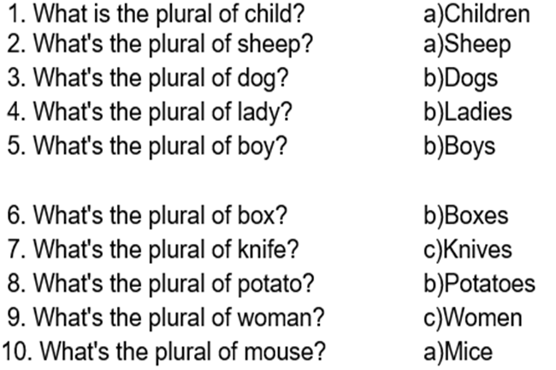

Quiz 2-2: (10 questions)
Answer a), b) or c)
1. Is there __________ cheese left? A. Any B. The C. Some
2. To make a pancake, you need _____ eggs and flour. A. An B. Much C. Some
3. How _________ cars are we taking? A. A lot B. Many C. A few
4. Excuse me. I need ________ information about the trains to Hanoi.
A. Any B. A few C. Some
5. For lunch, I had a salad and a ___________ of pizza today.
A. Some B. Slice C. Piece
6. How __________ rice do we have left? A. Much B. A C. Do
7. It's cold. Don't open _______ window. A. Some B. A little C. Any
8. Please, buy me a __________ apples for the cake. A. Few B. Little C. Some
9. Is there _________ time left? A. Many B. Much C. Some
10. It's too __________ for me. I can't eat it all. A. Much B. Many C. Some

Quiz 2-2: answers:
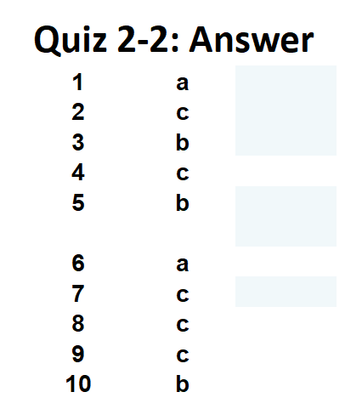1 \a

Quiz 2-3: Answer only a), b) or c).
01. What's the plural of shop? a) Shopps b) Shopes c) Shops
02. What's the plural of bush? a) Bushs b) Bushes c) Bushies
03. What's the plural of wife? a) Wifes b) Wives c) Wifies
04. What's the plural of book? a) Bookies b) Bookes c) Books
05. What's the plural of baby? a) Babys b) Babyes c) Babies
06. What's the plural of tooth? a) Tooths b) tothes c) Teeth
07. What's the plural of watch? a) Watchs b) Watches c) Watchies
08. What's the plural of bus? a) Bus's b) Buses c) Busies
09. What's the plural of foot? a) Foots b) Footes c) Feet
10. What's the plural of wolf? a) Wolfs b) Wolfes c) Wolves

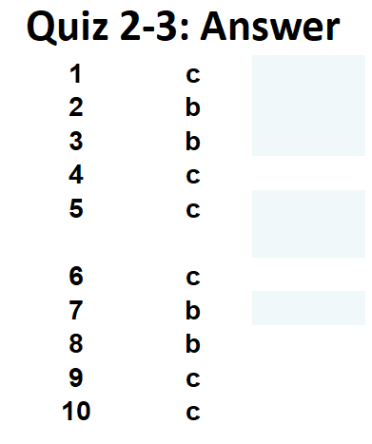

Quiz 2-4: Answer only a), b) or c).
1. There's ___________ coffee in the pot. A. Any B. Some C. A few
2. The plants need __________ more water. A. Any B. Some C. a few
3. I could not solve ___________ of the Maths problems.
A. Any B. Much C. A
4. Is there ___________ solution to this problem?
A. Some B. Little C. Any
5. Is there __________ cheese left? A. Any B. The C. Some
6. To make a pancake, you need ________ eggs and flour.
A. An B. Much C. Some
7. How _________ cars are we taking? A. A lot of B. Many C. A few
8. Excuse me. I need ________ information about the trains to Hanoi.
A. Any B. A few C. Some
9. For lunch, I had a salad and a ___________ of pizza today.
A. Some B. Slice C. Piece
10. How __________ rice do we have left? A. Much B. A C. Do

Quiz 2-4: - Answers:
